Headstone Photo Editing Guidelines
General:
- One photo for each single or double (or family) headstone.
- The same photo may be referenced by multiple records. A photo should not be duplicated under a second name in order to be referenced by two (or more) records.
- When photographing headstones at a cemetery section, photos were often taken of temporary markers or of patches of grass. This was done so that a photo existed for each plot location, to simplify tracking of the photos. These are not headstones and should be skipped.
  - For plots with a temporary marker, enter “yes” in the Need Photo column of the burial record, as a permanent headstone has likely been erected since the photo was taken.
- If the photo does not depict the entire headstone, process the photo as best possible and enter “cut off” (if the photo is missing a portion of the stone) or “partial” (if only half of a double headstone appears in the photo) in the Need Photo column of the burial record.
- If the inscription on a headstone is partially (or fully) obstructed by flowers or shrubbery, process the photo (regardless of the obstruction) and enter “obstructed” in the Need Photo column of the burial record (to indicate that a new photo is required).
- If the photo is blurry but still somewhat legible, process the photo and enter “blurry” in the Need Photo column of the burial record. If the photo is too blurry to be legible, do not process the photo and enter “yes” in the Need Photo column.
- If there’s any other reason why you think a new photo should be taken (and there’s no need to be hesitant of noting such a request, as we will need to take photos for new burials at every cemetery section regardless) or if the inscription is not legible, note this in the Need Photo column (e.g., “contrast”, “illegible”) so that a new photo can be taken. [It’s especially important to note the reason, and not simply “yes”, so that extra effort can be made to make the inscription legible (e.g., squirting with water, taking multiple photos from different angles, adjusting lighting).]

- Two headstones mounted on one base stone are considered to be the same as a double headstone. [“Base stone” refers to the granite or stone base (typically unpolished) on which the headstone is mounted. It does not refer to the concrete foundation (typically flush with ground level) on which the base stone sits.]
CORRECT | INCORRECT
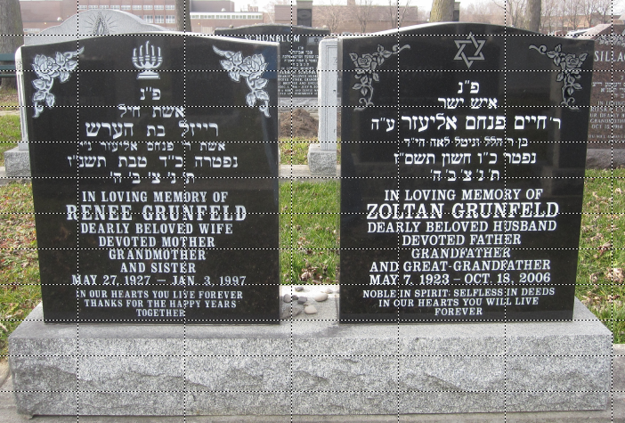 | 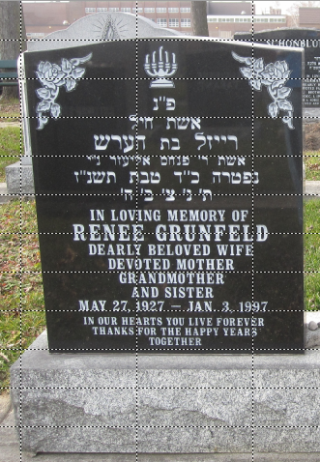

- Two adjacent headstones on separate base stones should be cropped into two separate photos.
CORRECT | INCORRECT
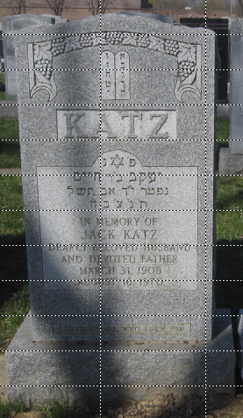 | 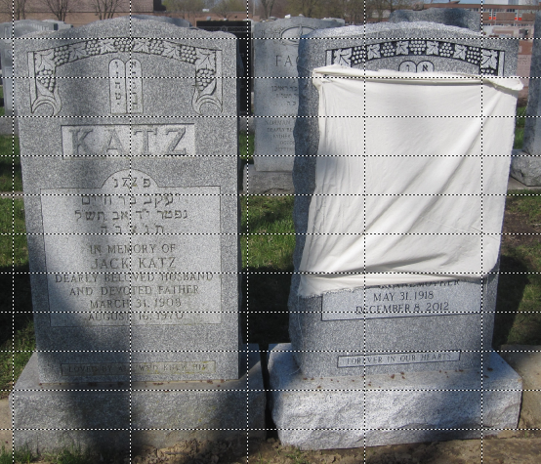

Rotation:
- Rotate the photo so that a primary line of text (e.g., family name, line with Hebrew name, line with English name) is level. Priority should be given to the primary line which is nearest the middle of the stone.
- Turning on the software’s grid (or guide) functionality will simplify this process.
- Rotate in 1° increments. Don’t worry about being more precise (i.e., rotating by 1.3° is not necessary).
- In some cases, rotation will result in blank areas around the edges; this is fine.
BEFORE | AFTER
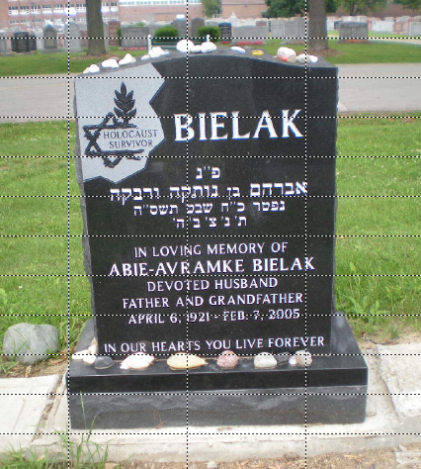 | 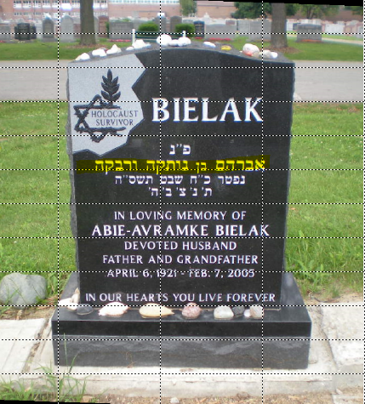
- Highlighted line (in yellow) was used as the baseline
- Note the small blank areas (solid black) at the bottom left and top right corners of the photo

Cropping:
- Include the entire headstone, including the base, in the photo, with minimal borders.
- Try to make the left and right borders of equal width.
- Include sufficient additional space above the headstone so as to avoid cutting off memorial stones.
- It is recommended to crop after rotating the photo.
BEFORE | AFTER
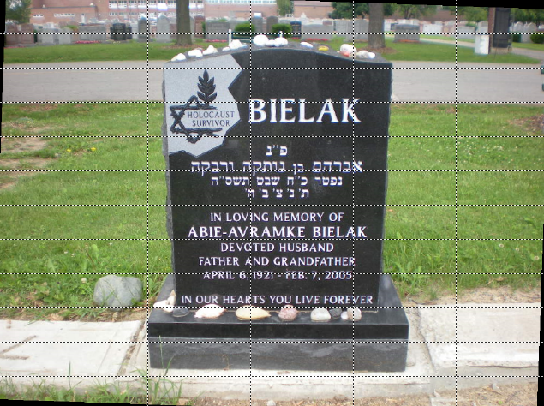 | 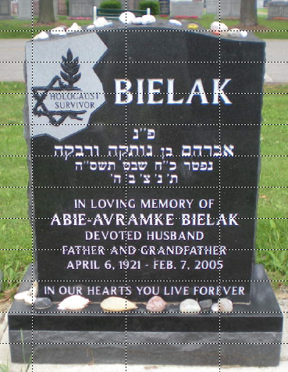

AVOID
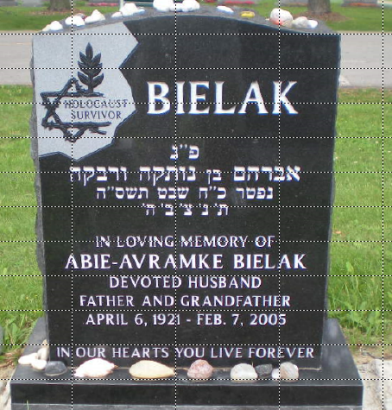
- Base is cut off
- Left and right borders are unequal
- Memorial stones on top of stone are cut off

Resizing:
- Maximum file size for JOWBR is 500 Kb.
- Older photos (taken at lower resolution) will probably not need to be resized in order to be smaller than 500 Kb.
- High resolution photos will most likely need to be resized in order to be smaller than 500 Kb.
- Resize to the largest possible image size such that the overall file size is less than 500 Kb.
- Because JOWBR photos are displayed with a height of 320 pixels, it is best to resize photos to a height which is a multiple of 320 pixels: 1600, 1440, 1280, 1120, 960, 800, 640
BEFORE | AFTER
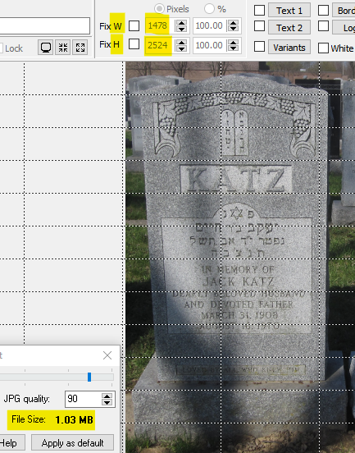 | 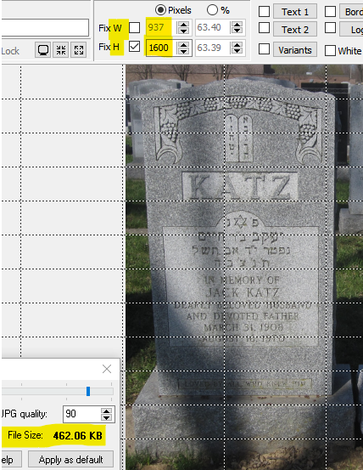
- Note the file size of 1.03 Mb with image size of 1478 × 2524 | - Setting the image height to 1600 pixels (resulting in a width of 937 pixels) results in a file size of 462.06 Kb, which is an acceptable file size  - If the file size had continued to exceed 500 Kb, the next step would have been to reduce the image height to 1280 pixels

File Naming:
- Each photo is to be uniquely identifiable (across all cemeteries and sections). The file name consists of a prefix, a location identifier, and an optional suffix, as follows (the italicized portions are optional):
CCSS_BRRGGx
CC cemetery identifier: two uppercase letters, e.g., BL = Bathurst Lawn Memorial Park; DR = Dawes Road Cemetery; RL = Roselawn Avenue Cemetery
SS section identifier: typically a two-digit number, occasionally followed by a letter, and sometimes a single letter or a three-digit number; any letters are uppercase
_ the underscore character, which serves to separate the cemetery/section designation from the location identifier (individual burial plot designation)
B (optional) sub-section identifier, when necessary, e.g., S = south, N = north, SW = southwest; all letters are uppercase
RR row or line identifier: depending on the cemetery and section, this could be a single digit, a two digit number, a single letter, two letters, or a combination (e.g., A1 or 1A); all letters are uppercase
GG grave or plot identifier: most often a two-digit number (sometimes followed by a single letter), occasionally a single letter or a single digit; all letters are uppercase
x (optional) suffix: JOWBR only permits one photo to be uploaded for each burial record. However, often multiple photos are required to properly document the grave. The two most common situations are headstones which have inscriptions on both the front and the back sides and graves where there are multiple markers (e.g., a headstone and one or more footstones). For some headstones, it may also be necessary to take multiple photos in order to fully document the inscription.
The “primary” photo (i.e., the one for which no suffix is added) should be the one which depicts the full front-side of the headstone. Additional photos (e.g., a close-up of a section of the headstone, or a footstone) are named with the identical file name with the addition of a (lower-case) suffix, e.g., a, b, c.
The following suffixes are defined for specific circumstances:
g – a photo of the gravesite (e.g., a photo depicting a headstone and footstone)
j – a composite photo (combining two or more individual photos) created specifically for upload to JOWBR
v – a photo of the back side (verso) of a headstone
- References to a particular cemetery section will use only the characters preceding the underscore. Thus, for example, BL01 refers to section 1 (Ivansker Mutual Benefit Society) of Bathurst Lawn Memorial Park, BL02 is section 2 (Husiatner Klaus) at Bathurst Lawn, and BL17A is section 17A (Agudath Israel) at Bathurst Lawn.

- The use of the sub-section identifier can sometimes be confusing, and sometimes it will depend on the numbering scheme being used by a particular cemetery.
  - For example, at Mount Sinai, many of the sections are divided into North and South sub-sections, and the same row/grave number combination is used in both sub-sections. Thus, at Mount Sinai, we will have photos named MS03_N0201 and MS03_S0201 which refer, respectively, to row 2 grave 1 on the north side and on the south side ... but both are part of section 3 (Sunnyside Cemetery Association). In this case, the N/S sub-section identifier appears after the underscore.
  - Conversely, at Dawes Road, there are sections which are named with an N or S extension (also denoting north/south), and in these cases we will have photos named DR006N_0215 and DR006S_0201 which refer, respectively, to row 2 grave 15 in section 6N (Beth Tzedec Congregation) and to row 2 grave 1 in section 6S (Anshei Slipia). In this case, the N/S is part of the section identifier, and so appear before the underscore.
- In general, the photo to be uploaded to JOWBR should be that which includes the decedent’s name in both English (or other language) and Hebrew (if present) and the date of death. In most cases, this will be the primary photo of the headstone.
  - If the front of the headstone is in Hebrew and the back of the headstone contains the same information in English (or vice versa), then three photos should be created: primary (front of the headstone), ‘v’ suffix (back of the headstone), and ‘j’ suffix (a composite photo consisting of photos of both the front and the back of the headstone). The ‘j’ suffix photo will be the one uploaded to JOWBR.
  - If the back of the headstone contains a memorial inscription or an indication that the decedent was a Holocaust survivor or other meaningful information, then two photos should be created: primary (front of the headstone) and ‘v’ suffix (back of the headstone). The primary photo will be the one uploaded to JOWBR. [Only if the back of the headstone contains dates of birth and/or death or an alternate given or family name not noted on the front of the headstone would it be necessary to create a ‘j’ suffix (composite) photo for upload to JOWBR.]
  - If a headstone bears only the family name, with the remaining information inscribed on a footstone, then three photos should be created: primary (front of the headstone), ‘a’ suffix (footstone), and ‘j’ suffix (a composite photo consisting of photos of both the front and back of the headstone). The ‘j’ suffix photo will be the one uploaded to JOWBR.
  - If a headstone bears the inscription in one language, with the inscription in the other language on a footstone, then three photos should be created: primary (front of the headstone), ‘a’ suffix (footstone), and ‘j’ suffix (a composite photo consisting of both the primary the ‘a’ suffix photos). The ‘j’ suffix photo will be the one uploaded to JOWBR.
- For photos of a double (or family) headstone, the photo should be named with the lower-numbered of the two graves, even if the lower-numbered grave is not yet occupied. For example, for a headstone for row 2 graves 5 and 6, the location identifier would be 0205.

File Saving:
- Photos should be saved as .jpg format.
- Exif metadata (which includes the original date/time stamp of the photo and any gps data) should be included.
- Compression can be set as low as 90% (as this will reduce the file size with barely any impact to the photo quality or resolution).
Recording the File Names:
- On the burial record, record the photo file name(s) as follows:
  - In the Front Photo Filename column, record the primary file name only if it is not being used as the JOWBR upload file (e.g., if the headstone shows only the family name, and the decedent’s information is inscribed on a footstone).
  - In the Reverse Photo Filename column, record the file name of the photo of the back of the headstone (which should have the ‘v’ suffix). It is not necessary to save a photo if the back of the headstone only shows the same family name recorded on the front of the headstone and no other information.
  - In the JOWBR Photo Filename column, record the file name of the photo which is to be uploaded to JOWBR. In most cases, this will be the primary file (showing the full front of the headstone). In some cases, this will be a footstone photo (likely having an ‘a’ suffix) and the primary file name will be recorded in the Front Photo Filename column. If a composite photo is required (whether created yet or not), record the composite file name (with a ‘j’ suffix) in the JOWBR Photo Filename column.
  - Any additional photo files which have been created (and not recorded in any of the first three columns) can be recorded in the Addition column. Separate the file names with commas or semi-colons if there are multiple additional photos.
- It is not necessary to include the .jpg extension in the file name columns.
- Record the need for a photo to be retaken – for whatever reason – in the Need Photo column. Any other comments can also be recorded in this column, as all non-blank entries will be reviewed.

Setting up Click2Crop (if it is being used):
- Select Guides / T Cross to display centre and middle guide lines in the file preview.
- Select Guides / Grid Over Preview to display grid lines in the output file preview. Select Guides / Preview Guide Setup… to specify the grid settings (e.g., Lines by interval; 40 horizontal; 120 vertical; Dotted lines).
- Select Edit / Preferences to define the file saving options:
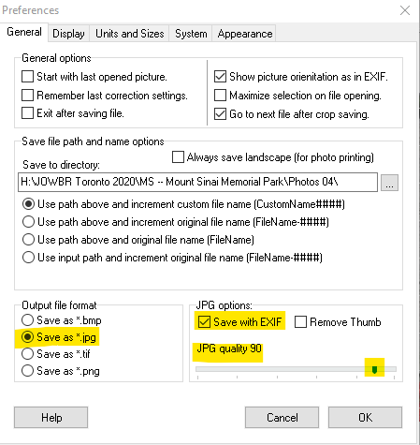

- Show JPEG Compression Expert and position it out of the way on the screen and leave it open so as to preview the file size:
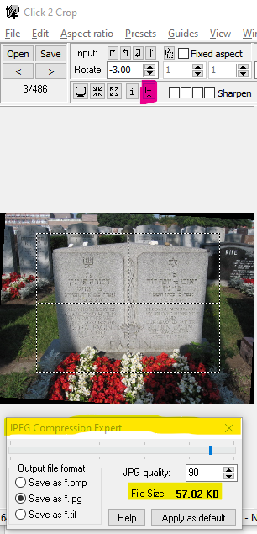
Clicking on the button highlighted in pink opens the JPEG Compression Expert dialogue box (highlighted in yellow) which can be positioned anywhere on the screen and displays the file size.

- Ribbon menu bar: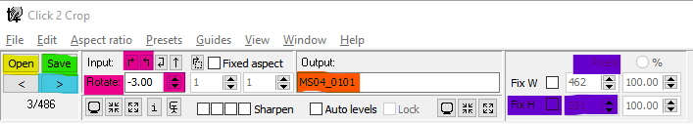
  - Click on the Open button (highlighted in yellow) to open the first file in the directory containing the original photos for a section.
  - Use the pink-highlighted up/down buttons to rotate the photo in 1° increments. If necessary, the pink-highlighted arrows will rotate the photo by 90°.
  - To specify the photo height in pixels, check the Fix H checkbox (highlighted in purple), select the Pixels radio button, and enter the desired height in pixels (e.g., 1600).
  - Specify the output file name in the red highlighted area.
  - Click on the Save button (highlighted in green) to save the cropped/modified file in the pre-defined output file location using the specified output file name (highlighted in red) AND advance to the next file in the input file directory.
    - The output file directory is specified under Edit / Preferences on the General tab.
    - Click on the “Use path above and increment custom file name” radio button to increment the output file name (this will not necessarily be the correct file name – especially for a double headstone – but is still useful).
    - To enable auto-advance, check the “Go to next file after crop saving” on the Edit / Preferences / General tab.
  - Click on the greater-than arrow button (highlighted in light blue) to advance to the next photo without saving (e.g., when viewing a duplicate photo for a double headstone, or a photo of a temporary marker).

